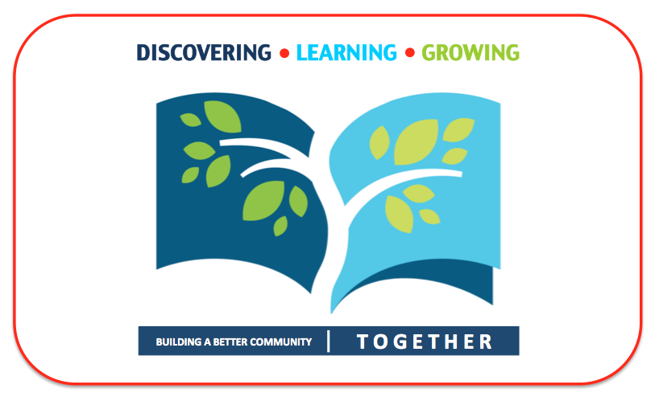

A COMMUNITY-CENTERED STRATEGIC DIRECTION

2016 – 2019
LIVERPOOL PUBLIC LIBRARY
STRATEGIC PLAN

TABLE OF CONTENTS

Executive Summary ………………………………………………………………… 3

Strategic Planning Process ………………………………………………………… 4

Community Profile ………………………………………………………………… 7

Core Beliefs and Purpose ………………………………………………………….. 8

Community Aspirations …………………………………………………………… 10

Strategic Focus …………………………………………………………………… 11

Next Steps and Accountability …………………………………………………… 12

Appendices:

The following documents support the development of the Liverpool Public Library Strategic Plan:

LPL Community-Driven Strategic Planning Timeline

LPL Action Plan: Strategic Areas of Focus, Priorities, Action Items, and Timeframes

Executive Summary

This Strategic Plan coincides with a new era for the Liverpool Public Library (LPL), as the Library welcomes a new Director and new members to the Board of Trustees, and bids farewell to a number of long-tenured staff who are retiring. This juncture provides an opportunity to take a fresh look at Library services and staffing in relation to the changing needs of the Liverpool community, and to develop a strategic plan that continues to meet the diverse needs of the Library’s service area today and into the future.

With a long history of delivering successful programming and services, this plan is focused on a process of continuous improvement. The plan is designed to build onto and align Library services, staffing and structure with the targeted needs of the community in order to have an even greater impact on the people throughout the Liverpool service area.

To fulfill that goal, the strategic planning process turned outward to the community, enabling library staff to hear firsthand from library and non-library users about their aspirations and base strategic decisions on community member needs and interests. This process lead to three areas of strategic focus:

- Learning and Education: Based on the Library’s ongoing success in educational programming and services from birth through lifelong learning, the Library is well positioned to serve a critical role in aligning these programs and services in support of the Liverpool Central School District’s strategic goals and objectives.

- Connecting the Community: As a hub for community programming, the Library can shape and lead community and civic engagement efforts throughout the broad service area in support of a more connected community district wide.

- Re-imagining the Library: This point of change provides an opportunity to evaluate and align the organizational structure and staffing to ensure community-wide success in the 21st Century both inside and outside of the library walls.
These three areas are the foundation of this plan and set the strategic direction for the Library.

Strategic Planning Process

Methodology

In this time of great change and reinvention for libraries across the country, the Strategic Plan seeks not to predict, but to set a strategic direction that will enable library staff to adapt to changing conditions and meet the 21st Century needs of community members.

To accomplish this task, the Liverpool Public Library consultant team worked very closely with Library senior management, staff, the Library Board, and community members while following a Community-Centered Strategic Planning Process.

This approach starts by gaining a clear understanding of what we believe in − why we exist (the library’s mission for the community), the communities that we serve − and leads to outcomes. It combines both strategic thinking and strategic planning in order to align the areas of strategic priorities and objectives and stay focused on milestones and outcomes.

To gain an understanding of the community, the consultant team incorporated a methodology from the Harwood Institute for Public Innovation. This approach, called “Turning Outward”, is described as, “a step-by-step process that entails taking steps to better understand communities; changing processes and thinking to make conversations more community-focused; being proactive to community issues; and putting community aspirations first.”

- Strategic Thinking: Analyzes influencing factors both inside and outside the library to discover the strategic direction. This strategic direction guides the library’s decision-making and resource allocation.

- Strategic Planning: Operationalizes the strategies and initiatives developed through strategic thinking and formalizes a plan that is specific and detailed.
COMMUNITY CENTERED STRATEGIC PLANNING
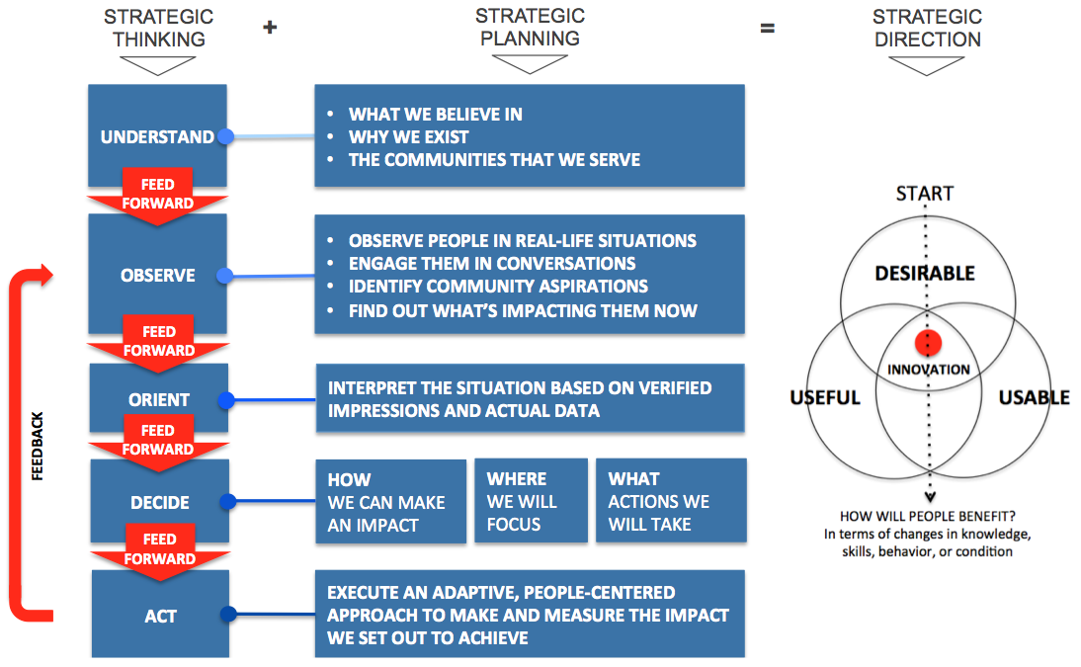
Phases

The phases involved in this approach include:

Phase 1: Demographic Research and Analysis

The Strategic Planning process started with an analysis of library usage in relation to the demographics of the LPL service area. By leveraging Analytics on Demand (AOD), a library data analysis tool, in conjunction with circulation data, the Library was able to establish a baseline of library usage and non-usage throughout the service area by demographic. It is important to note that programming attendance data was not available and therefore not factored into this initial research. Since this is a significant amount of library usage, this data would have an impact on usage statistics by demographic and is a strategic focus going forward.

Phase 2: Staff Communication & Participation

An all-staff meeting was held at the Library to kick-off the planning process. The purpose of the meeting was to:
- Engage staff in the planning process
- Share the findings from the AOD research
- Identify the Library’s core values
- Discuss the Library’s purpose within the community
- Validate the Library’s mission and vision
This initial phase was vital to open the channels of conversation during the planning process and engage the staff to take ownership in the plan and have a shared understanding of the process. This group meeting also enabled staff to share their thoughts on ideas on the Library’s mission and vision and work collectively to develop the Library’s core values.

Phase 3: Community Conversations and Ask Exercises

Using the Harwood approach, library staff, management and consultants conducted Community Conversations and informal Ask Exercises throughout the Liverpool service area. In addition to diverse community members, the strategic planning process engaged members of the school board and administration, the Superintendent of Liverpool School District, local and state government officials and representatives, the business community, and local associations, including faith-based organizations. The goal of these “kitchen table” conversations was to:

- Understand community aspirations and respond with creativity and innovation.
- Base strategic decisions on community member needs and preferences.
- Position the Library as a community leader whose influence extends far beyond the physical location.
- Create a forward-thinking organization that maximizes the potential of each staff member.
To solicit feedback from a broad cross section of the community, these conversations were held both inside and outside of the Library, including at churches, in restaurants, at a Chamber of Commerce meeting, in the schools, and at the YMCA.

Phase 4: Strategic Planning

Leveraging community feedback, staff input and data, the Library was ready to move into the initial strategic planning phase. At this phase, members of the library management team met to review and discuss the finding, learn and discuss best practices in leading libraries, and apply these insights to begin to shape the areas of strategic focus and strategic priorities.

Executive Leadership also leveraged the information and ideas discussed to re-evaluate the Liverpool Library staffing model in light of pending retirements with a goal of structuring the library within the context of the needs of the community.

Phase 5: Staff Engagement

This strategic plan differed from prior plans in the deeper level of communication with staff and overall increase staff input and participation. An all-staff meeting was conducted to provide an update on the status of the planning process and areas of strategic focus, and solicited input in terms of strategic priorities and action items.

This working session proved pivotal to engaging staff in helping to shape the direction of the library and opening channels to a more collaborative working environment across the organization.

Phase 6: Formalizing the Strategic Plan

This phase formalized the plan and established strategic priorities, action items, owners, teams and deadlines. Although this is the final stage in the formal planning process, this strategic plan is designed to be a living document, with strategies and priorities shifting as appropriate.

To move the process forward, the Strategic Plan is accompanied by an Action Planner, providing a manageable way to stay on track and meet goals and objectives set forth in the plan and make adjustments as needed.

community profile

The data analysis phase leveraged Analytics on Demand (AOD), a library data analytics tool. The analysis validated some assumptions and uncovered a few surprises. As anticipated, the data confirmed that the Liverpool service area matches the overall demographic of the Central New York region, with an aging population and shrinking young family base. Library patron data matches this trend, with higher circulation among an “Aging in Place” demographic.

Of interest in the findings was that library usage (based on circulation) uncovered a fairly even split throughout the entire service district, spanning from the village where the library is located up through the Northern tip of the service area. These findings were different than expected, as results were expected to show a concentration of usage down in the village. Also of interest was an even split among users and non-library users within the same neighborhoods, rather than pockets of usage clustered in a single area.

Going forward, the analytics provided in this tool enable the Library to strategically pinpoint marketing and community outreach efforts down to unique households and match the messaging to the demographic profile of that location. The results also provide a baseline for measuring the outcome of marketing and outreach activities over the next few years.

It is important to note that the analytics do not include patrons and non-patrons attending library programs, which is a significant portion of library usage among all demographics. The ability to track program attendance is one of the strategic priorities noted in this plan.

For detailed results, please see the Appendix.

Core beliefs and purpose

This process provided an opportunity to validate the Library’s core beliefs and purpose against staff and community perceptions, as well as to establish core values.

Mission

The mission statement is a statement of purpose – establishing the organization’s reason for being.

As part of the planning process, staff and management evaluated the mission statement within the context of a community-focused approach to service. Within this context, the core wording in the LPL mission statement was found still valid. However, the statement was edited slightly to turn outward to the community, rather than focusing inward to the library building.

The minor wording adjustment changed the purpose of the Library from serving as a community “space” where the focus is on the physical building, to serving as a community leading organization whose influence extends far beyond the walls of the building. The edit also changes the language from passive (“to be where the community connects”) to actionable (“to connect our community”)

This edit aligns with the expressed needs of the community become more connected throughout the district and enables the Library to align its strategic direction beyond the physical space.

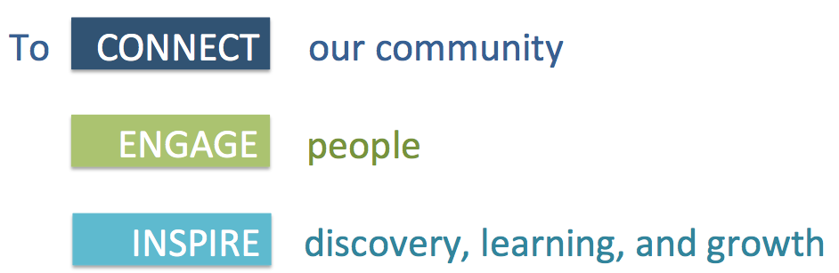

Vision

A vision statement defines the long-term aspirations for the library and identifies what success will look like in the future.

During the planning process, the Vision statement was adjusted to align with the aspirations of the community in order to achieve collected success in the future. Based on input from the community and library staff, the vision for the Liverpool Public Library is to play an integral role in creating:

A VIBRANT, ENGAGED, AND CONNECTED COMMUNITY

Values

Establishing the Library’s core values sets a benchmark for how the staff and trustees present themselves and behave both individually and as a group. This is an important aspect of the strategic planning process as it establishes how the Library interacts, with each other, with members of the community, and the personality they want to present.

Exercises and discussion with staff at all levels uncovered the following common core values:

What We Believe In (How We Respond):

Community
We connect people with information, resources, and each other.

Learning
We encourage learning as a life-long activity and believe it is our role to help create an educated community.

Innovation
We create dynamic environments through constant and purposeful change.

Collaboration
We work together and build relationships to strengthen our community.

COMMUNITY ASPIRATIONS

The community conversations and “ask exercises” held throughout the planning process were focused primarily on aspirations for the Liverpool community, with secondary input on how the Library can play a role in creating change.

Regardless of the varied demographics, common aspirations rose to the top in conversations:

- A welcoming, friendly, and more connected community: Suburban sprawl past the original Liverpool village footprint has created sub-communities within the Liverpool service area, resulting in a common feeling that the original “small town” and “welcoming” feel has dissipated and there is a geographic disconnect. This feeling is compounded by the rising number of rental properties with a more transient population.
During all of the conversations, the focus gravitated toward creating opportunities for organizations and leadership to work together to establish events and opportunities to form a more connected community.

- An educated, family-oriented and safe community: Among residents of all ages, there was a common desire to live in an educated community that offers affordable, family-focused events and learning opportunities. These conversations often dovetailed into or from the desire for a more connected and welcoming community.

Conversations with school affiliates indicated a need and desire to fill gaps during after school hours and during the summers with children, young adults, and teenagers when school is not in session. As the Library runs successful programming for children birth through graduation, interest was also expressed in supporting the Liverpool Central School District’s focus on 21st Century Skills as outlined in the school district’s strategic plan.

- A vibrant, culturally diverse, and progressive community: The desire for more cultural and civic events and a more vibrant community was expressed, particularly among empty-nesters and those in the 60+ demographic. This also overlapped with the desire for elected officials and other organizations to work together to nurture creativity and progress.
With respect to the library, the overall feedback was positive, with community members noting the number of well-attended and diverse programs, as well as the welcoming and friendly attitudes of Library staff. It is important to note that conversations focused less on what the library should be doing to contribute to the community, and more on how the library could extend and expand services throughout the service area to have an even greater impact.

These conversations were the first phase in a long-term and ongoing initiative to talk to people from all segments and open channels with organizations throughout the community in order to adapt and target programs and services based on interests and needs.

STRATEGIC FOCUS

Based on the key statements above, the team identified three key areas of strategic focus that forms the foundation of the strategic plan:

Below are the highlights of those initiatives:

ONE: Learning & Education

- Position the library as a leader in learning and education in the LCSD Service Area
- Align with the LCSD in support of their strategic plan
- Work with the school and organizations within the community to help identify and address gaps in learning and education (Birth / K – 12)
- Support lifelong learning and skills training in adults (18 and up)
TWO: Connecting the Community

- Shape and lead community and civic engagement in the LPL service area
- Establish and nurture community partnerships to enable community organizations, including the Library, and community members to work closer together
- Increase visibility and accessibility of library programs and services throughout the service area
- Enhance communication and outreach efforts to have a broader impact and higher visibility among library users and non-users

THREE: Reimagining the Library

- Align LPL’s organizational structure and staffing to meet community needs and ensure success in the 21st Century
- Evaluate the library building and surrounding property against current and future needs
- Replicate and expand library services beyond the library building to bring the “library” out further into the community

Specific strategic initiatives and action items within each of these areas are detailed in the scorecard included in the Appendix.

Next Steps & Accountability

As with any plan, the success of this strategic plan hinges on accountability, action and follow-through. As such, for each action item listed above, there are specific owners, teams and projected completion dates.

To ensure this stays a viable, living document, the Library Director will make these action items a part of applicable meeting agendas with staff and the management team. “Process Owners” will also assume responsibility for overseeing and meeting the stated objectives and deadlines with full participation from their affiliated team members.

Recognizing that plans must be flexible and dynamic in order to address the ongoing needs of members, these meetings will also provide an opportunity to adapt components of the plan as determined necessary by the Liverpool Public Library management team.

The assigned owners, teams and dates are included in the Appendix.

